This page not for release to Client
Effective date: 10/2001.
Notes to Preparer for Completing this SOW

This is the standard version of the GS Method Business Intelligence Strategy and Planning Phase Release 3.0 CAD SOW to be used for agreements with a customer on a time and materials basis in performing a GS Method Business Intelligence Strategy and Planning Phase engagement.

Use of this SOW SmartMaster
[NOTE: Although this SOW "template" has been reviewed as a starting baseline (not approved as final transaction) by IGS HQ Quality Assurance and Global Contracts & Negotiations, all proposal transactions using this template must complete the WWQA/MD process for quality assurance (QA 1, 2 and 3) and pricing approval for your geography and/or organization.]
This SmartMaster was developed to speed and simplify the creation and modification of IBM Statements of Work (SOWs). You may customize the SmartMaster content and save your work as a Lotus WordPro (.LWP) file using the normal File, Save. If you save the document as Lotus AmiPro (.SAM) or MS Word file, some of the formatting may be lost. To see formatting more clearly, use View, Set View Preferences, Show, then check "All" in the Show Marks pull down.
Preloaded Content
This SmartMaster contains basic language used in IBM SOWs including:
Cover page
Key Statement of Work components
Signature page.
Paragraph Styles
The paragraph styles used in this SmartMaster follow one of these formats:
A where-used description followed by the style attributes including point size, bold/italics, paragraph spacing, and justification (e.g. "Title (14 bold ctr)" translates to a style meant for use as a document or page Title in 14 point size with bolded text centered on the page. Text that is indented from the left margin includes the amount indented such as .25, .5, .75. 1.0. and 1.25 (inches). Spacing refers to the space above and below lines and is typically single (no space) or 1-1/2 (an added 1/2 line above and below).
A unique name indicating a specific purpose (e.g. "Draft note" used to highlight or flag temporary notations for later deletion; this section uses the Draft note style).
Paragraph styles set the overall look and feel of a paragraph but may be overridden by highlighting a word, string of text, or complete paragraph and changing its properties in the WordPro Text Properties dialog box (press Alt + Enter).
Styles are selected by placing the cursor anywhere in a paragraph, opening the Text properties dialog box, clicking the style tab (the colorful "S" inside of a tag symbol), and selecting the style from the list, or by selecting the style from the Menu Bar at the bottom of your workspace (place your cursor anywhere in this red text and look for "Draft note" below. Overridden styles may be removed by highlighting the complete paragraph and pressing the "Reset to Style." button.

Before giving the document to the customer, adjust page breaks!

When you have added final content to the document and are preparing it for final presentation to the customer, look at the way the pages break and be sure that they don't break in a clumsy location. Page breaks are already in place at the end of the cover letter, SOW body, appendices, and signature page.
To add a page break: position the cursor where you want the break to appear and press Ctrl + Enter. To remove one, highlight it with your cursor and press Delete.

This page not for release to Client
The table below describes the basic style types in this SmartMaster, their use and provides some examples. All text is Times New Roman.
Type | Typical Use | Format and Examples
Titles | Used in the cover page or at the beginning of unnumbered sections | Title (14 bold 1-1/2 ctr) is a 14 point bold heading with 1 1/2 spaces between lines centered on the page  Title (14 single ctr) is a 14 point normal text title centered on the page
Numbered Headings | The principle heading used in the SOW. These follow a 1.1.1.1 numbering format and numbering is automatically assigned and controlled | Head 1 (14 bold left) is level 1 numbered heading  Head 1.1 (14 bold .5) is level 2 numbered heading indented .5 inch from the left margin  All headings are line spaced at 1-1/2 inches
Bold and Bold Italics | Used when bolded unnumbered text is required | Bold .25 (10 1-1/2) is a 10 point bold heading indented .25 inches from the left margin  Bold Italics (11 1-1/2 .5) is an 11 point bold italicized heading indented .5 inches from the left margin
Body text | The default style for the SmartMaster, body text is both single and 1-1/2 spaced | Body (10 single left) is 10 point single-spaced and is used for all left margin text.
Bullets and Checks | Bullet styles use a small round bullet and are left justified and indented .25, .5, .75 and 1.0 inches  Checks use the check mark bullet style and also indented  (Indented text may be used after a bullet or heading (e.g. Bullet (10 1-1/2 .5) followed by Indent (10 1-1/2 .5) or Head 1.1 (14 bold .25) followed by Indent .25 (10 1-1/2) | Bullet 1 and Check 1 are indented .25 inch, Bullet 2 and Check 2 move in to .5 inches, etc.
Numbered list | Numbered text | Be cautious with the use of this style in multiple sections - check the numbering and override as necessary
Indented text | Following Headings, bullets and bold text styles | Indented text may be used after a bullet or heading (e.g. Bullet (10 1-1/2 .5) followed by Indent (10 1-1/2 .5) or Head 1.1 (14 bold .25) followed by Indent .25 (10 1-1/2
Appendix | Appendix headings | Appendix (14 bold left) is a 14-point heading spaced at 1-1/2. These headings increment automatically
Special purpose | Temporary notations | Draft note is a red text style that the SOW author may use highlight temporary notations during the draft or review and approval processes (they are to be deleted prior to giving the document to the customer)

This page not for release to Client

Content Variables
Content variables are standard fields or data that are normally present in a Statement of Work. WordPro Global replace (Edit, Find & Replace Text or Ctrl + F) may be used to find and quickly customize the SmartMaster to meet your specific needs. If a variable is listed as Optional and you choose not to use it, you'll need to use Find (Ctrl + F) to find and delete all occurrences of the variable.
Variable | Where Used | Replace With
<PROJECT NAME> | Throughout | Customer's project name
<SOLUTION NAME> | Throughout | Proposed Solution Name
<CUSTOMER NAME> | Throughout | Customer/client name
<Address 1> | Cover page, signature page | Customer's address: street
<Address 2> | Cover page, signature page | Customer address: city, state, Zip
<Customer Location> | Key assumptions section 3.2 | Customer city or facility
<Date-of-Proposal> | Throughout (document footer) | The effective date of the SOW
<Optional Logo> | Cover page | Use copy and paste or import to insert a graphic (optional)
<IBM Office Location> | Cover page | IBM office location (optional)
<Reference Agreement> | Section 3 introduction, Signature page | Either the IBM Customer Agreement (ICA), or the International IBM Customer Agreement (IICA)
<Doc Ref> | Throughout (document footer) | Number you wish to use to track or control this document (optional)
<Our Understanding> | Project Scope section 3.1 | Highlights our understanding of client goals, priorities, needs and wants
<MM/DD/YYYY> | Throughout | Various dates whose value is determined by the specifics of the engagement/proposal
<NN> | Throughout | Indicates that a number should be included.
<Pricing Assumptions> | Estimating and pricing backup section | Assumptions affecting pricing
<Signature variables> | Signature page | Customer number, Customer address, Office address

Notes to Proposal/SOW Author
Type I / II Deliverable Materials Language

If the Reference Agreement is:
The standard US IBM Customer Agreement (ICA), or other standard Country ICA which includes reference to "Type I and Type II materials", or standard IBM International Customer Agreement (IICA) (Z125-5379-03, dated 3/2001, or later version), no changes are required to this SOW.
The standard IBM International Customer Agreement (IICA) (Z125-5379-02, or earlier version), or a Country ICA which does not include reference to "Type I or Type II materials, the words “Type II” should be deleted from this SOW. For additional guidance, please see your C&N Advisor or Legal Counsel.
A modified ICA or IICA or any other negotiated Agreement, please see your C&N Advisor or Legal Counsel for guidance."
In addition, you'll see the line:
"Modify this section to reflect the specific needs of your opportunity!"
when modification of the associated section required or recommended (Make sure you delete this line after you're done).
Modifications made to the standard language provided in the Charges section require review by your quality assurance representative. Non-standard language may result in invoicing requirements that are impossible or costly to administer, and (based upon the judgment of the QA reviewer) it may be necessary for these to be evaluated by the NSSO/CSO organization to determine whether the non-standard invoicing procedure is feasible and whether a surcharge should be applied.

In Appendix D - Signature Document, include:
Customer signature line
Customer name (printed)
Customer sign date
Customer Number
Customer Address
IBM signature line
IBM name (printed)
IBM sign date
IBM Office Address
Add and complete any additional fields that are customary or required by local law for your geography in an appropriate place on the Signature Page. Some examples of such fields are: IBM Office Number, additional <CUSTOMER NAME> or IBM Authorized Signatures, VAT Number, or Commercial Register Number.

This page not for release to Client
Estimating and pricing backup
You can use the table below to determine the estimated number of hours that will be required for your Business Intelligence Strategy and Planning phase engagement. Make sure you consider the following when you determine your estimates:
Project Management hours should be spread through each of the tasks with additional time allotted for general PM activities such as project planning, issues management, and client management.
Include time needed to prepare and review work products and deliverables.

Activity | Band 10 Hours | Band 9 Hours | Band 8 Hours | Band 7 Hours | Band 6 Hours | Totals
Initiate BI Strategy & Planning
Review Business & IT Environment
Identify Solution Areas
Define Business Solution Strategy
Define Technical Solution Strategy
Outline Architecture Model
Assess Infrastructure Impact
Confirm BI Strategy & Planning
Total Hours | 0 | 0 | 0 | 0 | 0 | 0

Note: The hourly rate to be used in Section 3.8 Charges (which when multiplied by the total number of hours gives the total cost of this engagement), must be obtained from your local authorized pricer.

Additional variables appear in the Charges section. They are:
Variable | Where Used | Replace With
<Number of hours> | Charges section 3.8 | Total number of hours estimated
<Hourly rate> | Charges section 3.8 | The blended hourly rate (replaced with a table if separate rates are quoted (optional)
<Fee total> | Charges section 3.8 | The total estimated fee
<Travel fee estimate> | Charges section 3.8 | Normally expressed as a percentage of the total fee. Standard is 20%.

This page not for release to Client
Deliverable and Global Services Method Work Product Linkages
This section describes the linkage and relationship between the deliverables in this SOW and the Work Products in IBM's Global Services Method. It is intended for use by the Proposal Team Lead and the Project manager/team only.
Proposal Team Lead - Use as a baseline for estimating during Solution Design. Please note that the time estimates for each work product will vary by project and may require adjustment.
Project Manager/team - Use to establish the initial project plan and requirements for the project team. Consult the appropriate method reference material for detailed descriptions of Work Products and the complete listing of activities and tasks to assist with project planning.
The table below identifies the recommended Solution Outline Deliverables for each activity and the associated Global Services Method Work Product outputs that comprise them. The last column in the table identifies Work Products that are not included in the standard Deliverables, but that the team may need to produce in order to complete their work. For example, the Project Workbook Outline guides the work to be performed by the team and is used as an internal document; however, it is generally not a Deliverable for the client.

This table shows the recommended linkages between the defined Deliverables and the Global Services Method Work Products. You may not need to produce all of the listed Work Products for a Deliverable, depending on your engagement. For example, your project may not require that you develop a Business Event List as part of the Business Model Deliverable. In this case, you would omit the Business Event List. Or, if a Deliverable requires Work Products that are not listed in the table below, you will need to add them. If you feel that additional deliverables or Work Products are required to meet the needs of your engagement, make sure you adjust the SOW activities, deliverables, and estimates to allow for the additional work. The decisions regarding which Work Products will be needed for the engagement should be made as part of a Proposal Adoption Workshop (PAW) or Method Adoption Workshop (MAW).

Solution Outline
Activity | Client Deliverables | Related Global Services Method Work Products (outputs) | Global Services Method Work Products (outputs) not included in Deliverables (but are produced if needed for the team)
Project Management | Bi-Weekly Status Report | Project Status Report  Cost Schedule  Risk Management Plan  Project Management Schedule  Change Order  Action Log  Issue Log | Project Estimates  Operational Schedule  Risk Definition  Quality Review Documentation
Initiate Solution Outline | Overview of Project Approach  (Some of these Work Products are produced as part of the Solution Startup phase of 9PMM that performs the project start, but may be refined in this activity) | Project Definition  Project Management Schedule  Deliverable Definition  Risk Management Plan | Project Workbook Outline  Project Estimates  Operational ScheduleQuality Plan for Application Domain  Project Quality Plan  Candidate Asset List  Risk DefinitionWork Breakdown StructureOrganizational Breakdown Structure  Human Resource Plan
Review Client Environment | Business Model | Business Environment  Business Event List  Process Definition  Business Rule Catalog | Classified Business Terms  Current Organization Description  Strategic Direction
 | Current I/T Environment Report | Current I/T Environment  Standards
Outline Solution Requirements | Requirements Report | System ContextUse Case Model  Non-functional Requirements  User Profiles  Usability Requirements | Current Solution Evaluation  Change Cases  Viability Assessment  Use Case Validation Report  Static Test Plan
Outline Application Model | Application Model  NOTE: Selection of which Work Products are used as parts of this deliverable depend largely on whether the application will be developed with structured or object oriented techniques. | Class Diagram (object oriented approach)  System Function Model (structured approach) | Analysis and Design Guidelines (both approachs)  Logical Data Model (structured approach)  Process / Data Usage (structured approach)
Outline Architecture Model | Architecture Model  Viability Assessment | Component Model  Operational Model  Viability Assessment | Architecture Overview Diagram  Architectural Template  Reference Architecture Fit/Gap Analysis  Candidate Asset List  Architectural Decisions  IT Services Strategy  Parametric Costs  Performance Model  Service Level Characteristics Analysis
Assess Business Impact | Business Impact Assessment | Change Readiness Assessment  Impact Analysis | Current Organization Assessment  Process Definition  Customer Wants and Needs
Outline Solution Strategy10 | Solution Strategy  NOTE: All solution plans are developed at a high level during Solution Outline. They will be refined and detailed in later project phases. | Release Plan (high level)  Education and Training Strategy  Deployment Plan (high level)  Usability Design and Evaluation Plan  Test Strategy  IT Services Strategy | Configuration Management Procedures10  Software Distribution Plan  Benefit Impact Analysis
Confirm Solution Outline | Macro Design Project Plan  NOTE: All deliverables and their component work products should be finalized and delivered as part of this activity. | Project Estimates  Project Management Schedule  Phase Deliverables (outcome) | Quality Review Documentation  Delivery Control Documentation

This page not for release to Client
Verify the Additional T&C’s Section

If you need to insert Definitions in the SOW, insert them into the “Additional T&C’s” Section.

Pages for release to Client follow below

IBM Global Services Proposal
for
<SOLUTION NAME> Business Intelligence Strategy and Planning

Prepared for
<CUSTOMER NAME>
<Address 1>
<Address 2>

<Date-of-Proposal>

<Optional Logo>

The information in this Proposal shall not be disclosed outside of <CUSTOMER NAME> and shall not be duplicated, used or disclosed in whole or in part for any purpose other than to evaluate the proposal, provided that if a contract is awarded to IBM as a result of or in connection with the submission of this proposal, <CUSTOMER NAME> shall have the right to duplicate, use or disclose the information to the extent provided by the contract. IBM retains ownership of this proposal. This proposal is valid for 30 days from the date above.

IBM Global Services
<IBM Office Location>

Updating the Table of Contents
The use of styles in this document enables you to generate and update a Table of Contents automatically. After this document has been approved for presentation to the customer and all variable data has been changed or removed, carefully follow the steps below:
- Open the Generate or Update Table of Contents dialog box using Create, Other Document Part, Table of Contents pulldown menu above.
- Press the Update button.
- Highlight all of this red text and press the Delete key to remove it from the page.

1. Overview and Approach 6
1.1 IBM’s Approach 6
1.2 IBM Assets and Intellectual Capital 6
2. IBM Statement of Work for BI Strategy and Planning 6
2.1 Project Scope 6
2.2 Key Assumptions 6
2.3 IBM Responsibilities 6
2.3.1 Project Management 6
2.3.2 Initiate BI Strategy and Planning 6
2.3.3 Review <CUSTOMER NAME> Business and IT Environment 6
2.3.4 Identify Solution Areas 6
2.3.5 Define Business Solution Strategy (REDW Impact) 6
2.3.6 Define Technical Solution Strategy 6
2.3.7 Outline Architecture Model 6
2.3.8 Assess Infrastructure Impact 6
2.3.9 Confirm BI Strategy and Planning 6
2.4 <CUSTOMER NAME> Responsibilities 6
2.4.1 <CUSTOMER NAME> Project Manager 6
2.4.2 Initiate Business Intelligence Strategy and Planning 6
2.4.3 Review <CUSTOMER NAME> Environment 6
2.4.4 Outline Solution Requirements 6
2.4.5 Outline Application Model 6
2.4.6 Outline the Architecture Model 6
2.4.7 Assess Business Impact 6
2.4.8 Outline the Solution Strategy 6
2.4.9 Confirm Business Intelligence Strategy and Planning 6
2.5 Deliverable Materials 6
2.6 Completion Criteria 6
2.7 Estimated Schedule 6
2.8 Charges 6
2.9 Additional Terms and Conditions 6
2.9.1 Economic and Monetary Union (“EMU”) 6
2.9.2 Required Consents 6
2.9.3 Data Protection 6

Overview and Approach
Modify this section to reflect the specific needs of your opportunity!
This should be an executive-level description of the project and this Statement of Work. It should quickly and concisely describe the situation and our approach to conducting the project. It’s important that you know your audience and target this section to that audience. Here are points to keep in mind:

Choose words carefully; don’t conflict with the scope as defined later in the Statement of Work (SOW) section of this document. While not part of the legal contract, this section can often do much in setting or re-setting expectations.
Make certain that the overview does not include items like “turnkey solution” or terms that sell the proposal beyond what we will deliver. Customer responsibilities of the owning the final system or solution are often scaled back, once they see that IBM is their “total solution provider”.
This section should be the “connector” from the proposal and marketing discussions up to now, and clearly explain why IBM is now formally proposing a contract. If this SOW follows a prior engagement, this section should be a lead in to the next phase of the solution.
Make sure we can deliver on the promises in this overview.
This section should also sketch out the flow of steps for the solution. This will help to level set the reader on the work we are and what they can expect on the project. A high-level overview of the Global Services Method and the phases covered by the SOW would be appropriate for this section.
The following is a list of words/phases that should be avoided or used with extreme caution when writing Statements of Work and proposals:

Words that imply guarantees or warranty, such as
Complete
Guarantee
Words ending in "sure" i.e., insure, assure, ensure

Phases that promise things outside scope or control:
Increase competitiveness
Satisfy/meet future business needs

Words that have a specific legal meaning:
Partner/Partnership
Alliance
Guarantee
Best efforts

Superlatives:
Greatest, least, best
Optimum, minimum, maximum
Earliest

Words that imply perfection:
Unique
Any, every, all, none
Always, never
“Uniquely qualified”

Words that leave a task or list open to interpretation such as:
Includes (there may be more as determined by the reader)
But not limited to
For example, e.g., etc.

Words that may imply more capability than we are delivering
High performance
Real Time Access
Highly Scaleable
High Availability

The following is a standard overview for the Business Intelligence Strategy and Planning phase of the Global Services Method. This can be incorporated into the Executive Overview. You still should include a description of the situation (why we are doing this project) and a description of the project we are conducting, in addition to this overview. If you use the standard Global Services Method overview make sure you modify this as needed for your engagement! Remove any activities that you are not going to do, add any additional information that is needed, etc.

IBM is the world's largest information technology company with approximately 150,000 services professionals and 45,000 business partners in 164 countries. A significant portion of all the corporate data in the world is managed by IBM software, making IBM a logical choice to assist customers in delivering custom application development.
Make sure you check the IBM website for the latest facts and figures!
IBM Global Services is a world-class systems integration and solution delivery organization. We are at the forefront of translating new technologies into customer solutions and bringing to an engagement a complete set of business-focused offerings that include:
Services ranging from outsourced business processes and end-to-end industry solutions, to fully integrated custom applications.
Customizable assets that may be rapidly deployed to help customers meet fast-emerging needs and short-window opportunities.
Best-of-breed hardware and software products.
We bring years of expertise to every project. We apply our experience in developing similar solutions in the past to help develop your solution. By using technology and knowledge that we already have in house, and adapting them to <CUSTOMER NAME> needs, we can often help reduce elements of the estimated development costs and time.

IBM’s Approach
Our approach for developing a solution is driven by an integrated methodology offering well-established Project Management and technical delivery methods. These proven methods provide the framework for managing the IBM project team and helping to keep the project on track. IBM's Project Management methods address key management concerns and are designed to provide high quality results and help keep projects on time and on budget. The following areas are addressed by our method:
Scope and Change Management
Project Planning
Risk Mitigation
Deliverables Management
Configuration Management
Issues and Actions
Quality
Communications
Defect Management
Our technical method, called IBM Global Services Method, helps provide the technical method to engineer quality solutions. The Global Services Method, a component of IBM's Worldwide Solution Design and Delivery Methods (WSDDM) provide a flexible project approach that utilizes proven development methods and processes for building customer application solutions. Specifically it:
Is focused on project outputs and their relationships which allow the IBM project team to fine tune the approach used to create them to help meet specific customer requirements.
Helps provide a basis that is designed to avoid classic development mistakes such as insufficient planning and/or risk management, feature creep, failure under pressure, and a lack of management controls.
Is adaptable to project phase enabling discipline to be applied even when joining a project mid-phase.
Provides a positive basis for project management, sound estimation techniques, repeatability and the leveraged reuse of project outputs such as documents, models, diagrams, and program code.
IBM’s approach to designing and developing custom applications is multi-phased, each phase building upon those that preceded it. This incremental and iterative approach allows IBM to further refine both the design and the release strategy before construction begins and allows IBM to help you assess the viability of the solution in each phase throughout the engagement. In addition, since each phase is generally performed under separate SOWs, you may elect not to proceed to another phase and thus you will be contractually obligated to only the phase(s) where you have signed a specific SOW.
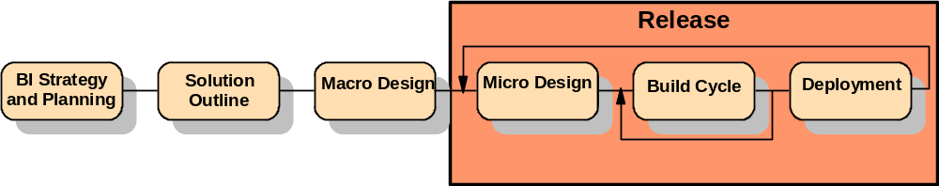The major phases of the approach are depicted in the figure below, with descriptions of each phase following:
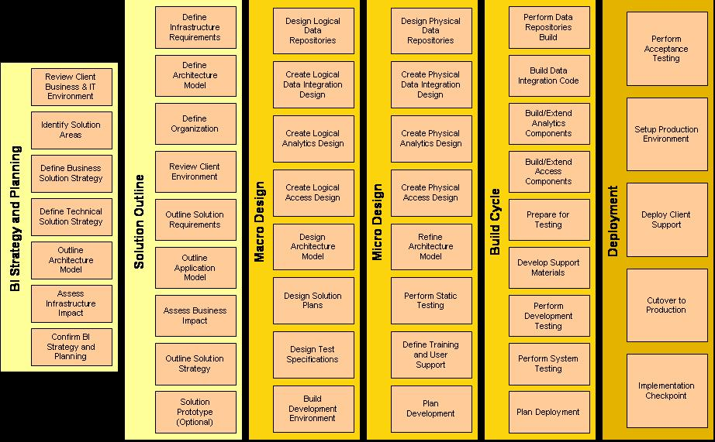
IBM conducts the Solution Outline and Macro Design phases as separate planning and high-level design projects. The Micro Design, Build Cycle and Deployment phases are then bundled together into a Release, which focuses on the detailed design, construction and deployment of the specific functions included in the application release.
REDW Impact to BI Method
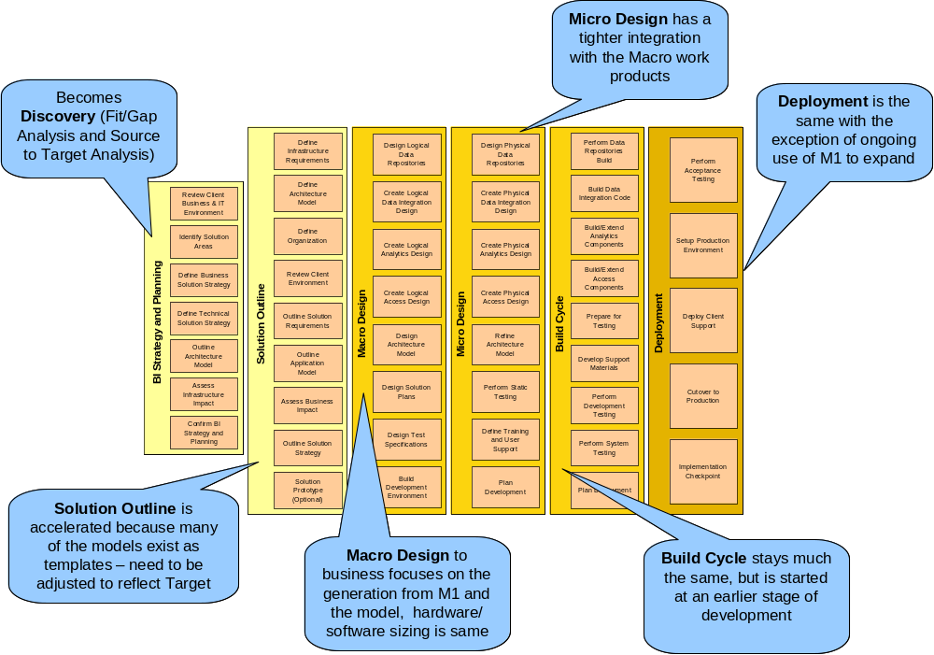

BI Strategy and Planning
The purpose of BI Strategy and Planning is to define and articulate an integrated Business Intelligence vision for the organization and adopt a common framework around BI needs, solutions and approaches.
The following are the major activities conducted during the Solution Outline phase:
Make sure you only list those BI Strategy and Planning activities that you will be completing on this engagement. The activities and tasks that you include should reflect the work that must be completed to develop the Global Services Method Work Products that you adopted during the Method Adoption Workshop. If you define more activities here than you include in the “IBM Responsibilities” section, the customer may expect that you are performing more work than you are.
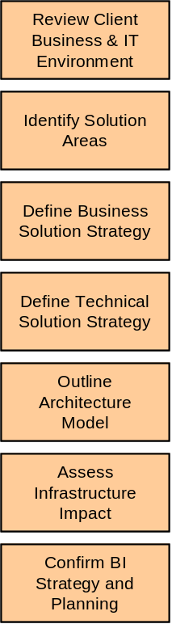

Review Client Business & IT Environment allows us to gain an understanding of the business, organization, and IT environment in preparation for identifying BI opportunities and developing several solution areas.
Identify Solution Areas identifies one or more solution areas, where each solution area represents a discrete project initiative with its own set of objectives, scope and intent. There is an initial prioritization of each defined solution area based on its relative importance and benefit to the business.
Define Business Solution Strategy defines the overall solution strategy based on the set of specific solution areas that offer value. This activity is performed in order to assemble the solution strategy according to solution area.
Define Technical Solution Strategy captures decisions about how business processes will be supported, identifies the scope of the system, and outlines infrastructure requirements.
Outline Architecture Model produces a high-level draft of the architecture and establishes a framework which guides the implementation of business intelligence solutions. It serves as the basis for the evaluation and planning of the end-state infrastructure.
Assess Infrastructure Impact identifies the gaps between the existing and required technologies, networks, IT processes, and IT skill sets, in terms of how they perform today and how likely they will meet the future business needs.
Confirm BI Strategy and Planning develops the overall strategy for moving forward with the solution outline, design and development effort.

Solution Outline
The purpose of Solution Outline phase is to provide a scoping phase, in which the solution complexity and scope are defined, and the overall strategy and approach for the design and development effort is developed. This allows IBM to provide you an estimate of the phase costs, schedule and other key information to help you make an informed investment decision regarding a potential new solution before additional resources are expended in more detailed work.
The following are the major activities conducted during the Solution Outline phase:
Make sure you only list those Solution Outline activities that you will be completing on this engagement. The activities and tasks that you include should reflect the work that must be completed to develop the Global Services Method Work Products that you adopted during the Method Adoption Workshop. If you define more activities here than you include in the “IBM Responsibilities” section, the customer may expect that you are performing more work than you are.
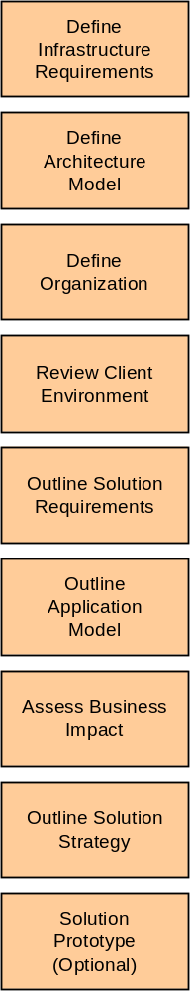
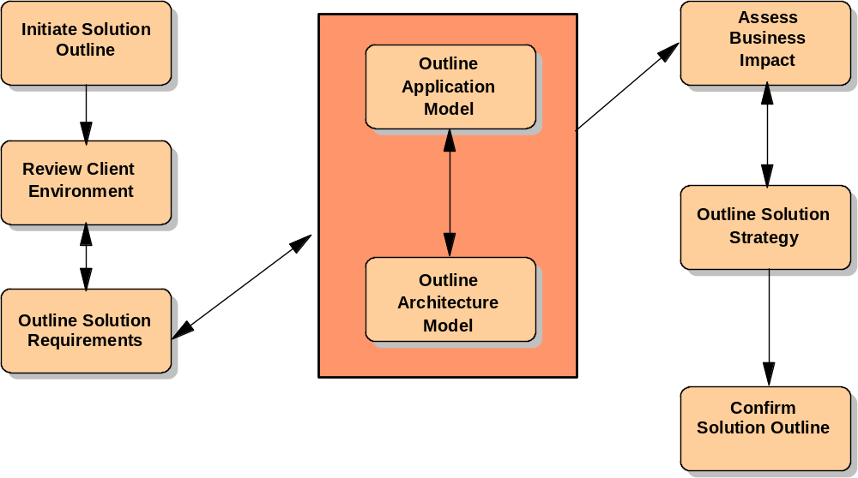

Initiate Solution Outline is performed to confirm the project scope, establish a detailed work plan, and to identify and assess relevant issues that might affect project feasibility.
Review Infrastructure Requirements outlines the requirements for the system and ensures that all future decisions reflect the business priorities.
Define Architecture Model formulates a high level, conceptual vision of the architecture for the overall <SOLUTION NAME> Solution.
Define Organization identifies the gaps between the existing and required technologies, networks, IT processes, and IT skill sets, in terms of how they perform today and how likely they will meet the future business needs.
Review <CUSTOMER NAME> Environment to gain an understanding of the <CUSTOMER NAME> business, organization and current I/T environment in preparation for recommending the <SOLUTION NAME>.
Outline Solution Requirements outline the requirements that must be met by the new <SOLUTION NAME> Solution and ensure that all future decisions reflect the business priorities.
Outline Application Model outline the <SOLUTION NAME> major application responsibilities and to develop a high level model of the major components (entities, relationships, and processes) of the proposed system independent of implementation.
Assess Business Impact to verify project feasibility by assessing the organization’s readiness to accept the new <SOLUTION NAME> solution and identifying organizational and cultural issues related to deploying the new <SOLUTION NAME>.
Outline the Solution Strategy to document strategies on all aspects of solution development, define the appropriate approach for the engagement process and document the compromises necessary to implement the system.
Solution Prototype (Optional) to reduce risk, analyze areas of unknown complexity or requirements, and investigate new technologies.
Confirm Solution Outline provides a detailed project plan and estimates for the follow-on phase and ensures that <CUSTOMER NAME> is still committed to the design and development effort.

Macro Design
The purpose of Macro Design phase is to lay the groundwork in preparing for the Release phases by developing an architecture, designed to withstand business changes through the delivery of the solution. Macro Design moves the focus from business to the solution’s technology strategy, addressing the global, architectural issues that affect all the releases. The standards, guidelines and architectural results developed in Macro Design phase are designed to help minimize long term development cost by reducing rework, from release to release.
The following are the major activities conducted during the Macro Design phase:
Design Logical Data Repositories
Create Logical Data Integration Design
Create Logical Analytics Design
Design Architecture Model
Design Solution Plans
Design Test Specifications
Build Development Environment
Create Logical Access Design
Initiate Macro Design
Refine Requirements & Application Model
Design User Interfaces
Design Architectural Model
Conduct Static Testing
Design Solution Plans
Design Test Specifications
Build Development Environment
Confirm Macro Design

Release Phases
Each application Release Phase is conducted in three sub-phases: Micro Design, Build Cycle, and Deployment. Each release is designed to produce a defined set of functions and architecture. These sub-phases are grouped together in an iterative cycle and performed for each defined solution release.
The detailed design for the release is produced in Micro Design. The Build Cycle executes the plans for building and testing the application according to the design specifications. Deployment implements the solution.
Micro Design
The purpose of Micro Design is to prepare for the build cycle of a specific release of the solution by driving the architecture and design to a release specific and implementation platform view. Micro Design is the first of three sub-phases repeated for each Release Phase of the solution. Whereas Solution Outline and Macro Design phases take a release independent view, Micro Design focuses on a specific release. Micro Design refines many of the same project outputs addressed in the prior two phases but narrows the scope to the release and goes to a greater level of detail.
The following are the major activities conducted during the Micro Design phase:
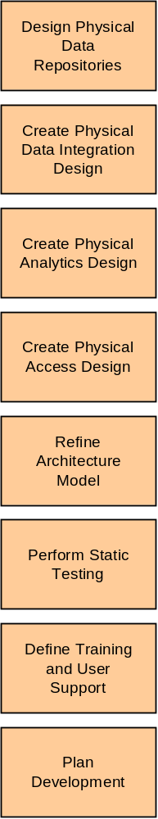

Initiate Micro Design
Detail Requirements & Application Model
Refine Architecture Model
Perform Static Testing
Detail User Interfaces
Define Training and User Support
Define Physical Application Model
Plan Development
Confirm Micro Design

Build Cycle
The objective of the Build Cycle sub-phase is the development and testing of the solution Release. This is an iterative phase with each Build Cycle containing several incremental programming and testing cycles. An assessment of business conditions and validation of the release strategy is performed before the construction of each release to provide an opportunity to adjust the design and release strategy to help respond to changes in scope. Changes in scope may change the cost and schedule and will be handled using change control.
The following are the major activities conducted during the Build Cycle:
Develop Support Materials
Prepare for Testing
Perform Data Repositories Build
Build Data Integration Code
Build/Extend Analytics Components
Build/Extend Access Components
Perform Development Testing
Perform System Testing
Plan Deployment
Initiate Build Cycle
Develop Support Materials
Prepare for Testing
Perform Programming Cycle
Perform Development Testing
Perform System Testing
Plan Deployment
Confirm Build Cycle

Deployment
The objective of this sub-phase is the managed roll out of the solution Release. The migration of users from other systems and the required data conversions also are managed in this phase. Each release is evaluated and the results fed back into the assessment of the next release. A pilot may be used to verify that each release functions as expected.
The following are the major activities conducted during Deployment:
Perform Acceptance Testing
Setup Production Environment
Deploy Client Support
Cutover to Production
Implementation Checkpoint
Initiate Deployment
Perform Acceptance Testing
Set Up the Production Environment
Deploy Client Support
Cut Over to the Production Environment
Review Solution Plans
Confirm Deployment

IBM Assets and Intellectual Capital
Among IBM's great strengths are the capabilities and experiences of its people and teams. Our
professionals have worked on complex projects ranging from multiple systems integration, to business process reengineering, to the deployment of the newest products and technologies. IBM values this knowledge and experience so much that we have developed a process to capture, manage and leverage this intellectual capital across the globe. The result is a networked community of professionals who can create, share, and build upon knowledge across time and distance. The potential benefits of this include the reuse of intellectual capital to shorten cycle times and increase innovation and creativity.

IBM Statement of Work for BI Strategy and Planning
This Statement of Work (SOW) describes the work to be accomplished by IBM under the terms and conditions of the IBM Customer Agreement, number ________(Agreement). In the event of any contradiction, inconsistency or ambiguity between the terms of the two documents, this Statement of Work shall govern. This Statement of Work and the Agreement (and any applicable Attachments) represents the entire agreement between the parties regarding the subject matter and replace any prior oral or written communications. The tasks to be performed by IBM are defined and an estimated schedule is provided. In addition, the responsibilities of <Customer Name> are listed.

Changes to this Statement of Work will be processed in accordance with the procedure described in Appendix B. Project Change Control Procedure. The investigation and the implementation of changes may result in modifications to the Estimated Schedule, Charges, and/or other terms of the Agreement.

The following are incorporated in and made part of this Statement of Work:
Appendix A. Deliverable Guidelines
Appendix B. Project Change Control Procedure
Appendix C. Deliverable Review and Sign Off Procedure
Appendix D. Signature Document

Project Scope
This Statement of Work addresses the Business Intelligence Strategy and Planning phase of IBM's application development approach.
In this phase IBM will:
This should be a clear concise description of the scope of the project. The rest of this SOW will provide the details for the scope statement. It should NOT be a repeat of the Executive Summary. Keep the following questions in mind when defining this statement:

What is the customer’s primary goal for the project?
What will we deliver at the end of this engagement?
What limits the engagement size - departments to be included, processes to be automated, etc.?
What are the estimating drivers for the engagement?

Key Assumptions
This Statement of Work, and IBM's estimates to perform this Statement of Work is based on the following key assumptions. Deviations that arise during the proposed project will be managed through the procedure described in "Appendix B. Project Change Control Procedure” and may result in modifications to the Estimated Schedule, Charges, and other terms.
This is the section where you define any assumptions the SOW and IBM’s estimates are based on. It is important to identify all assumptions you have for the engagement that could potentially impact IBM’s ability to successfully deliver the end result.
Some sample assumptions are provided below. Make sure you identify assumptions that are relevant to your engagement. Add any additional assumptions that are needed and delete those that are NOT needed!
- The <CUSTOMER NAME> Project Manager will schedule and ensure participation of all <CUSTOMER NAME> subject matter experts and technical personnel for all required interviews and work sessions.
- IBM estimates are based on the ___________ document dated <MM/DD/YYYY>.
- Some IBM tasks in this SOW may be performed by subcontractors.
- Work under this SOW will be performed at the <CUSTOMER NAME> facility in <Customer Location>.
- Some activities on this project may be performed on IBM premises. The time spent on these contract-related activities will be billable to <CUSTOMER NAME>.
- IBM will provide services under this SOW during normal business hours, 8:30 AM to 5:15 PM Monday through Friday, except holidays.
- <CUSTOMER NAME> is responsible for the identification and interpretation of any applicable laws, regulations, and statutes that affect <CUSTOMER NAME> application systems or programs, which IBM will have, access to during this project. It is the responsibility of <CUSTOMER NAME> to assure that the systems and programs meet the requirements of those laws.
- <CUSTOMER NAME> will provide suitable office space, supplies, furniture, and other facilities with telephone access for up to _____ IBM personnel while working on the <CUSTOMER NAME><PROJECT NAME>. The IBM project team will be located in an area contiguous to your subject matter experts and technical personnel and all necessary security badges and clearance will be provided for access to this area. A lockable four or five drawer cabinet will be provided to IBM personnel in accordance with <CUSTOMER NAME> security procedures. Required parking spaces will also be provided.
- The following tools have been specified for this project:
Tool 1 name,version # to be provided by ____________
Tool 2 name, version # to be provided by ____________
- __________ is not included as part of this Statement of Work.
- <CUSTOMER NAME> will accept IBM's standard invoice format and billing procedure.

IBM Responsibilities
This section defines the actual work IBM will perform under the SOW. The work should be defined with sufficient detail to provide a clear understanding of our engagement responsibilities and so that clear completion criteria can be defined; however, do not make it so detailed that we define each and every task the team will perform. Be careful about giving away your entire methodology or approach!
The activity descriptions provided below comprise the full Business Intelligence Strategy and Planning Phase. Your engagement may not include all of the activities listed. Use this template as a starting point for developing a SOW that is appropriate for your engagement!
The activities that you define in this section should be those activities required to complete the Global Services Method Work Products that the team will produce on the engagement. These will vary from engagement to engagement, depending on the work to be performed, client situation, and so on. The development of the SOW should always be preceded by an effort to tailor the Global Services Method for the specific engagement, either through a Proposal Adoption Workshop (PAW) or Method Adoption Workshop (MAW). During these workshops, the team will review the set of Global Services Method work products and select those that are needed to deliver the engagement. When the tailoring effort is completed, you should review this SOW template and make sure the work you are defining matches the work products that you are going to develop.
For each activity, the related Global Services Method Work Products are listed in red at the end of the description for the tasks that produce them. If, through the method tailoring, you have determined that certain Work Products will not be needed for the engagement, you should delete the tasks that produce those Work Products. In addition, you will need to delete the related information in Appendix A, Deliverable Guidelines as well.
After you have completed the SOW, make sure you delete all Work Product names shown in red before submitting the SOW to the client!
Under this Statement of Work, IBM will perform the following activities:

Project Management
IBM will provide project management for the IBM responsibilities in this Statement of Work. The purpose of this activity is to provide technical direction and control of IBM project personnel and to provide a framework for project planning, communications, reporting, procedural and contractual activity. IBM will perform the following tasks:
Planning
- Review the Statement of Work and the contractual responsibilities of both parties with the <CUSTOMER NAME> Project Manager.
- Maintain project communications through the <CUSTOMER NAME> Project Manager.
- Coordinate the establishment of the project environment.
- Establish documentation and procedural standards for Deliverables.
- Prepare and maintain the project plans for performance of this Statement of Work, which defines the activity, task, responsibilities, milestones and estimated schedule.
- Prepare for the <PROJECT NAME> project team orientation.
Project Tracking and Reporting
- Measure and evaluate progress against the Project Plan with the <CUSTOMER NAME> project manager.
- Resolve deviations from the Project Plan with the <CUSTOMER NAME> Project Manager.
- Conduct regularly scheduled project status meetings.
- Prepare and submit a Status Report bi-weekly to the <CUSTOMER NAME> project manager.
- Administer the Project Change Control Procedure with the <CUSTOMER NAME> project manager.
- Coordinate and manage the technical activities of the project personnel.
- Review project tasks, schedules, and resources and make changes or additions, as appropriate.
Completion Criteria:
This activity will be complete when the other activities described IBM Responsibilities have been completed, according to their completion criteria or IBM has met the criteria defined in Section 2.6 "Completion Criteria" of this Statement of Work.
Deliverables:
Bi-weekly Status Reports

Initiate BI Strategy and Planning
The objective of this activity is to confirm the <Project Name> project scope, and to identify and assess risks and issues that might affect the project feasibility. IBM will work with <CUSTOMER NAME> Project Manager to:
- Work with the <CUSTOMER NAME> Project Sponsor to document the business goals for the project. (Project Definition)
- Develop a detailed work plan for the <PROJECT NAME> and assign project resources to specific work efforts. (Project Management Schedule)
- Identify and assess areas of major risk and to develop mitigation strategies. (Risk Definition, Risk Management Plan)
- Conduct a workshop with the combined IBM and <CUSTOMER NAME> engagement team to orient the project team to IBM’s project approach and to the Deliverables that will be produced on the engagement. Duration of workshop is added to this paragraph.
- Conduct a project kick-off meeting with the project team and key stakeholders. Duration of meeting is added to this paragraph.

Completion Criteria:
This activity will be considered complete when the IBM Project Manager has completed the workshop and conducted the project kick-off meeting.
Deliverables:
Overview of Project Approach

Review <CUSTOMER NAME> Business and IT Environment
The purpose of this activity is to review existing documentation of client strategies, initiatives, systems etc in order to gain an understanding of the business, organization, and IT environment in preparation for identifying BI opportunities and developing several solution areas.

Based on the interviews conducted, IBM will work with <CUSTOMER NAME> to perform the following:

- Review/Research Client Business & IT Strategies, Existing Initiatives
- Establish Alignment with Performance Measurement Approach
- Define Business Context (Interviews, workshops, research)
- Identify High Level Business Requirements
- Define Business Issues and Goals
- Describe Current Organization and IT Architecture
- Document Client Business and IT Environment

Completion Criteria:
This activity will be complete when the Business Model and Current I/T Environment Report have been delivered to <CUSTOMER NAME> or IBM has met the criteria defined in Section 2.6 "Completion Criteria" of this Statement of Work.
Deliverables:
Current Environment Assessment

Identify Solution Areas
The purpose of this activity is to identify one or more solution areas, where each solution area represents a discrete project initiative with its own set of objectives, scope and intent. There is an initial prioritization of each defined solution area based on its relative importance and benefit to the business.
IBM will develop a <SOLUTION NAME> Solution Strategy document which outlines the following:
- Identify Opportunities and Desired Capabilities
- Outline Capability Enablers
- Identify Capability Gaps Shortcomings and Deficiencies
- Outline High Level Subject Area Model (BI)
- Outline Solution Areas
Completion Criteria:
This activity will be complete when the Solution Strategy has been delivered to <CUSTOMER NAME> or IBM has met the criteria defined in Section 2.6 "Completion Criteria" of this Statement of Work.
Deliverables:
High-level Subject Area Model

Define Business Solution Strategy (REDW Impact)
The purpose of this activity is to define the overall solution strategy based on the set of specific solution areas that offer value. This activity is performed in order to assemble the solution strategy according to solution area.
IBM will develop a <SOLUTION NAME> Solution Strategy document which outlines the following:
- Formulate a Cost/Benefit Impact Analysis (BI)
- Develop Solution Area Business Case
- Determine Solution Viability
- Define Solution Area Impact
- Develop Solution Area Release Plan (Roadmap)

Completion Criteria:
This activity will be complete when the Solution Strategy has been delivered to <CUSTOMER NAME> or IBM has met the criteria defined in Section 2.6 "Completion Criteria" of this Statement of Work.
Deliverables:
Business Case, Solution Definition, Solution Roadmap (REDW: Business Solution Modeling)
REDW Impact:
Definition
During this activity the objective is to produce a set of Business Solution Templates (BST’s) that have been customized to support the reporting requirements of the end users
Method
A set of interactive sessions between the REDW Consultant and the End User Representative(s) takes place, using the M1 tool, in order to Produce a Business Solution Model
Create a Retail Specific M1 Model
Save the ‘vanilla’ version of the M1 model with a bank specific name, e.g. RETLV10
Create M1 Views
M1 uses the concept of views to scope the BST’s. A view is used as the unit of OLAP cube outline and ERwin model generation so it is important that all the dimension and measure information required is included in the view definition.
It is likely that each user department may require different view definitions in order to simplify the scope; it is even simpler for each BST to have its own view.
If this is not the first iteration of the project then it is possible that existing BST’s are to be amended with additional dimensions and measures.
Scope Attributes into View
As each measure and dimension is identified as being required by the project, it may be scoped into the view definition. Upon OLAP or ERwin generation, these attributes will be included.
Document Dimension Members
M1 has the capability to store specific values for each attribute e.g. branches, products. This will be translated into the DB2 OLAP outline members.
OLAP Cube Granularity
Care and realism must be used during this task about the number of dimensions and the level of granularity of a particular dimension. The issue here is one of cube size. If the dimension Customer is included in the definition and there are 1 million customers, then the size of the cube will be prohibitive. It is recommended to hold only higher level customer information such as ‘customer type’ or ‘income level’ in order to reduce the populated cube size.
If customer or account level information is required to be analyzed then it may be necessary to use a relational data mart as the analytical data storage layer
Tools
M1 is the tool used during this activity to produce business requirements. M1 contains over 50 Business Solution Templates covering: Profitability, Relationship Marketing, Risk and Asset/Liability Management
Timescales
Each session with one Business Solution Template should take approximately ½ day.
Deliverables
A set of customized (and maybe new) Business Solution Templates that represent the ideal reporting solution for the end user. The next activity is to take those data requirements and attempt to find them in the source systems. In addition there will be a Business Requirements Document that summarizes the requirements for the implementation phase.

Define Technical Solution Strategy
The purpose of this activity is to capture decisions about how business processes will be supported, identifies the scope of the system, and outlines infrastructure requirements.
The IBM team will perform the following:
- Outline User Profiles
- Outline Metadata Strategy
- Refine Subject Area Model (BI)
- Determine Data Availability and Quality
- Develop External Data Reference Definition
- Define and Categorize Infrastructure Requirements
Completion Criteria
This activity will be complete when the Architecture Model and Viability Assessment have been delivered to <CUSTOMER NAME> or IBM has met the criteria defined in Section 2.6 "Completion Criteria" of this Statement of Work.
Deliverables:
Technical Solution Strategy

Outline Architecture Model
The purpose of this activity is to define a high-level draft of the architecture and establish a framework which guides the implementation of business intelligence solutions. It serves as the basis for the evaluation and planning of the end-state infrastructure. It ensures that the architecture is robust and flexible for the overall systems (all releases), which can easily adapt to changing business requirements.
The IBM team will perform the following:
- Develop High-Level Architecture Overview
- Survey Available Assets
- Develop High-Level Component Model
- Develop High-Level Operational Model
- Define Service Levels
- Reference Architecture Asset Gap Analysis
Completion Criteria
This activity will be complete when the Architecture Model and Viability Assessment have been delivered to <CUSTOMER NAME> or IBM has met the criteria defined in Section 2.6 "Completion Criteria" of this Statement of Work.
Deliverables:
Reference Architecture

Assess Infrastructure Impact
The purpose of this activity is to identify the gaps between the existing and required technologies, networks, IT processes, and IT skill sets, in terms of how they perform today and how likely they will meet the future business needs. This information is an essential prerequisite in planning the activities to build and support the future IT infrastructure.
The specific tasks to be performed by IBM in this activity are defined in the sections below:
- Develop Infrastructure Gap Analysis
- Develop IT Readiness Assessment
- Develop IT Org Skills Gap Analysis
- Document Job Roles and Responsibilities and Competencies
- Confirm Solution Areas Post Infrastructure Planning Impact
- Confirm Solution Area Release Plan
Completion Criteria
This activity will be considered complete when IBM delivers the Macro Design Project Plan and conducts a walk-through of the <SOLUTION NAME> Solution Strategy document with <CUSTOMER NAME>, or when IBM has met the criteria defined in Section 2.6 "Completion Criteria" of this Statement of Work.
Deliverables
Organizational Impact Analysis, BI Roadmap

Confirm BI Strategy and Planning
The purpose of this activity is to develop the overall strategy for moving forward with the solution outline, design and development effort, and gain client agreement to a BI Strategy and Plan (roadmap).
The specific tasks to be performed by IBM in this activity are defined in the sections below:

- Assemble Phase Deliverables
- Review Phase Deliverables
- Prepare Submission of Deliverables
- Harvest Reusable Assets
- Manage Acceptance
Completion Criteria
This activity will be considered complete when IBM delivers the Macro Design Project Plan and conducts a walk-through of the <SOLUTION NAME> Solution Strategy document with <CUSTOMER NAME>, or when IBM has met the criteria defined in Section 2.6 "Completion Criteria" of this Statement of Work.
Deliverables
BI Strategy

<CUSTOMER NAME> Responsibilities
This section defines the standard customer responsibilities on the engagement. These will vary from engagement to engagement, depending on the circumstances. Make sure the activities you list here match the activities defined in the IBM Responsibilities section. Use this template as a starting point - modify this section to reflect the specific needs of your opportunity!
The successful completion of the proposed effort depends on the full commitment and participation of <CUSTOMER NAME> management and personnel.
The responsibilities listed in this section are in addition to those responsibilities specified in the <Reference Agreement>, and are to be provided at no charge to IBM. IBM's performance is predicated upon the following responsibilities being fulfilled by <CUSTOMER NAME>.

<CUSTOMER NAME> Project Manager
Prior to the start of this Statement of Work, <CUSTOMER NAME> will designate a person called the <CUSTOMER NAME> Project Manager who will be the focal point for all IBM communications relative to this project and will have the authority to act on behalf of <CUSTOMER NAME> in matters regarding this project. The <CUSTOMER NAME> Project Manager's responsibilities include the following:
- Serve as the interface between IBM and all <CUSTOMER NAME> departments participating in the Project.
- Administer Project Change Control along with the IBM Project Manager.
- Attend weekly project meetings.
- Obtain and provide information, data, decisions and approvals within three working days of IBM's request unless <CUSTOMER NAME> and IBM agree in writing to a different response time.
- Resolve deviations from the estimated schedule, which may be caused by <CUSTOMER NAME>.
- Help resolve project issues and escalates issues within <CUSTOMER NAME>, as necessary.
- Schedule and secure attendance of all required <CUSTOMER NAME> personnel as required for interviews, meetings and work sessions. This is expected to include six (6) to eight (8) Subject Matter Experts and four (4) to five (5) Technical personnel for the work sessions.
- Provide access to relevant <CUSTOMER NAME> information and documents required for the project.
- Make final selection of solution and technical architectures.
- Review with the IBM Project Manager any <CUSTOMER NAME> invoice or billing requirements. Such requirements that deviate from IBM's standard invoice format or billing procedures may have an effect on price, and will be managed through the procedure described in "Appendix B: Project Change Control Procedure".

Initiate Business Intelligence Strategy and Planning
During this activity <CUSTOMER NAME> will:
- Validate that the business goals defined for the project are complete and accurate.
- Attend the orientation workshop to IBM’s project approach and to the Deliverables that will be produced on the engagement.
- Provide the IBM Project Manager with any <CUSTOMER NAME> milestones, dependencies, and related work plans that may impact the project. The <CUSTOMER NAME> Project Manager will develop project plans for any <CUSTOMER NAME> work to be conducted on the <PROJECT NAME> project and provide these to the IBM Project Manager.
- Schedule the project kick-off meeting, notify the <CUSTOMER NAME> participants who will be attending, and procure the necessary facilities and equipment for the meeting.
- Review and approve the following IBM deliverables:
- Overview of Project Approach

Review <CUSTOMER NAME> Environment
During this activity <CUSTOMER NAME> will:
- Provide business subject matter expertise to the IBM team. The IBM Project Manager will work with the <CUSTOMER NAME> Project Manager to define the interviews/meetings required.
- Schedule the interviews, send the required notification to interviewees, and procure space to conduct the interviews.
- Provide any existing documentation relative to the <PROJECT NAME> processes and this project. This will include items such as mission and vision statements, organization charts, process descriptions, IT standards, descriptions of currently installed hardware and software, and previous <PROJECT NAME> studies/efforts documentation. The IBM Project Manager will define the documents that are requested for the project as part of the project initiation.
- Provide a complete and accurate description of the <CUSTOMER NAME> current and planned software applications, technical infrastructures, and defined IT architecture and application development standards.
- Review and approve the following IBM deliverables:
- Business Model
- Current I/T Environment Report

Outline Solution Requirements
During this activity <CUSTOMER NAME> will:
- Provide input to the IBM team to define the <SOLUTION NAME> requirements. Also, provide subject matter experts to review the use cases, usability requirements, and non-functional requirements to validate they reflect the <CUSTOMER NAME> requirements for the project.
- Provide input relative to the different types of intended users for the <SOLUTION NAME> Solution and the characteristics for each type.
- Provide input regarding information exchanges that will be required between the <SOLUTION NAME> Solution and the external entities that will need to interface with the solution, including the information that must be input and/or output in the exchanges.
- Review and approve the following IBM deliverables:
- Requirements Report

Outline Application Model
During this activity <CUSTOMER NAME> will:
- Provide input to the IBM team to define the <SOLUTION NAME> Application Model.
- Review and approve the following IBM deliverables:
- Application Model

Outline the Architecture Model
During this activity <CUSTOMER NAME> will:
- Provide a subject matter expert to provide a high-level overview of the <CUSTOMER NAME> current IT infrastructure and development environment.
- Review and approve the following IBM deliverables:
- Architecture Model
- Viability Assessment

Assess Business Impact
During this activity <CUSTOMER NAME> will:
- Provide business subject matter expertise to the IBM team to conduct a high-level assessment of the <CUSTOMER NAME> organizational and I/T readiness to deploy the new <SOLUTION NAME> solution.
- Provide the IBM team with the skills assessments, human resources information, organizational descriptions, and other documentation that will be required to complete this activity.
- Review and approve the following IBM deliverables:
- Business Impact Assessment

Outline the Solution Strategy
During this activity <CUSTOMER NAME> will:
- Provide input to the IBM team, as needed, to complete this activity.
- Review and approve the following IBM deliverables:
- Solution Strategy

Confirm Business Intelligence Strategy and Planning
During this activity <CUSTOMER NAME> will:
- Identify the appropriate resources to participate in the Solution Strategy walk through of the <SOLUTION NAME> Solution Strategy deliverable, schedule the walk through session, and procure the required facilities and resources for this session.
- Review and approve the following IBM deliverables:
- Macro Design Project Plan

2.4.10 Data File Content and Security

<CUSTOMER NAME> is responsible for the actual content of any data file, selection and implementation of controls on its access and use, and security of the stored data.

2.4.11 Laws, Regulations and Statutes
(Note to Preparer: This should be included in All SOWs as a Customer Responsibility.)
<CUSTOMER NAME> is responsible for the identification of, interpretation of, and compliance with, any applicable laws, regulations and statutes that affect <CUSTOMER NAME>’s applications or business.

For services provided by IBM at your location, <CUSTOMER NAME> will permit posting of any notifications required by applicable law.

Deliverable Materials
All customer Deliverables for the engagement must be listed in this section and the appropriate Deliverable types (Type I, II, etc.) defined. Typical Deliverables are Requirements Reports, Solution Strategies, Business Models, Application Models, and Viability Assessments. The actual Deliverables you define in this section should focus on achieving the project goals and objectives.

Deliverables should be defined based on the Work Products you are producing on the engagement. It’s important to remember that not all Work Products have to be formal Deliverables!! One Deliverable may consist of several Work Products. Or you may produce some Work Products that are for the internal team’s use and not intended to be customer Deliverables; therefore, you do not want to list them in a Statement of Work. Remember, IBM is contractually obligated to deliver any Deliverables you define here!

The customer may require additional Deliverables that are not made up of Global Services Method Work Products. They may have a “special request” that is outside of the Global Services Method. These Deliverables also must be included here if we agreed to complete them.

(Note to Preparer: See C&N or Legal for guidance if using a Reference Agreement OTHER THAN:
The standard US IBM Customer Agreement (ICA); or
other standard Country ICA which includes reference to "Type I and Type II materials"; or
standard IBM International Customer Agreement (IICA) (Z125-5379-03, dated 3/2001, or later version.)
The following deliverables are classified as Type II Materials, as defined in the IBM Customer Agreement, and will be delivered to <CUSTOMER NAME> under this Statement of Work.

- Bi-weekly Status Report
- Overview of Project Approach
- BI Strategy & Roadmap
- Solution Definition, Solution Roadmap
- Business Case
- Technical Solution Strategy
- Organizational Impact Analysis
- Current Environment Assessment
- High-level Subject Area Model

If there are Type I deliverables required for the engagement, the following wording should be used. If there are no Type I deliverables, the text should be deleted from this document.
The following deliverables are classified as Type I Materials, as defined in the IBM Customer Agreement, and will be delivered to <CUSTOMER NAME> under this Statement of Work.

- Type I Deliverable 1
- Type I Deliverable 2

Completion Criteria
Completion criteria will vary, depending on whether the contract is Time and Materials or Fixed Price. Select the wording below that matches your engagement and delete the other before submitting the SOW to the customer!
The following wording should be used for Time and Materials contracts:
IBM shall have fulfilled its obligations under this Statement of Work when any one of the following first occurs:
- IBM accomplishes the IBM tasks described in "IBM Responsibilities,” including delivery to <CUSTOMER NAME> of the materials listed in section “Deliverable Materials".
- IBM provides the number of hours of services specified in "Charges" or in any subsequent Change Authorization.
- <CUSTOMER NAME> or IBM terminates the Project in accordance with the provisions of the Agreement.

The following wording should be used for Fixed Price contracts:
IBM shall have fulfilled its obligations under this Statement of Work when one of the following first occurs:
- IBM accomplishes the IBM tasks described in "IBM Responsibilities", including delivery to <CUSTOMER NAME> of the materials listed in section “Deliverable Materials".
- <CUSTOMER NAME> or IBM terminates the Project in accordance with the provisions of the Agreement.

Estimated Schedule
The services in this Statement of Work are estimated to be performed in a period of up to <NN> weeks from the agreed upon start date.

Charges
The wording in this section will vary depending on whether you have a Time and Materials or Fixed Price engagement.
The following wording should be used for Time and Materials engagements:
This engagement will be conducted on a time and materials basis.
IBM will provide up to a total number of <Number of hours> hours for this Service at an hourly rate of <Hourly rate> per hour. The estimated professional services charges for this Statement of Work are $ <Fee total> and are exclusive of any travel and living expenses and any applicable taxes.
<CUSTOMER NAME> will be billed actual travel and living costs estimated at <Travel fee estimate>% of professional services charges.
For IBM personnel resources that ultimately remain on the assignment for more than one year, or who perform services in countries other than where they are permanently assigned , there may be an increased tax burden pursuant to home and work jurisdiction tax laws. <CUSTOMER NAME> will be responsible for, and will pay, the increased expenses related to federal, state and local tax assistance provided to the affected resources. Application of the appropriate tax rules will be determined by IBM. The costs will be billed, when appropriate, with the travel and living expenses affected and incurred in the performance of the work scope detailed in this Statement of Work. In the case of services performed outside the personnel resource's permanent work country, there may be additional costs as a result of the international assignment program.
The hours specified above are IBM's estimate based upon the information available at this time. IBM will notify <CUSTOMER NAME> as soon as practical of any changes in our estimates.
IBM will invoice <CUSTOMER NAME> monthly. Invoices are due upon receipt.

The following wording should be used for Fixed Price engagements:
This engagement will be conducted on a fixed price basis.
The fixed price for performing the IBM tasks defined in the Statement of Work will be <Fee total>. The estimated professional services charges are exclusive of any travel and living expenses and any applicable taxes.
<CUSTOMER NAME> will be billed actual travel and living costs estimated at <Travel fee estimate>% of professional services charges.
<CUSTOMER NAME> will be invoiced in equal monthly amounts over the period of the performance specified in “Estimated Schedule”. <CUSTOMER NAME> will reimburse IBM for actual work performed through the date of cancellation.
For IBM personnel resources that ultimately remain on the assignment for more than one year, or who perform services in countries other than where they are permanently assigned , there may be an increased tax burden pursuant to home and work jurisdiction tax laws. <CUSTOMER NAME> will be responsible for, and will pay, the increased expenses related to federal, state and local tax assistance provided to the affected resources. Application of the appropriate tax rules will be determined by IBM. The costs will be billed, when appropriate, with the travel and living expenses affected and incurred in the performance of the work scope detailed in this Statement of Work. In the case of services performed outside the personnel resource's permanent work country, there may be additional costs as a result of the international assignment program.
IBM will invoice <CUSTOMER NAME> monthly. Invoices are due upon receipt.

Additional Terms and Conditions

Economic and Monetary Union (“EMU”)
(Note to Preparer: Include in any SOW for customers who have enterprise locations or other business dealings with entities in Europe.)
We are not providing any Economic and Monetary Union (“EMU”) services under this SOW. IBM Product Specifications specify the EMU readiness of the IBM Products. We do not make any representations regarding the EMU readiness of the non-IBM products. Under the terms of this SOW, we are not responsible for: (1) your products, (2) a third party’s products (including products you license from our subcontractors), or (3) our Products not provided and selected by us under this SOW (collectively “Other Products”) to correctly process monetary data in the Euro denomination. We will be relieved from our obligations under this SOW due to the inability of such Other Products to correctly process monetary data in the Euro denomination. You acknowledge that it is your responsibility to assess your current systems and take appropriate action to migrate to Euro-ready systems.

Required Consents

You shall be responsible for promptly obtaining and providing to IBM all Required Consents necessary for IBM to access, use and/or modify software, hardware, firmware and other products used by you for which IBM shall provide services hereunder. A Required Consent means any consents or approvals required to give IBM and its subcontractors the right or license to access, use and/or modify (including creating derivative works) your or a third party's software, hardware, firmware and other products used by you without infringing the ownership or license rights (including patent and copyright) of the providers or owners of such products.

You agree to indemnify, defend and hold IBM and its affiliates harmless from and against any and all claims, losses, liabilities and damages (including reasonable attorneys' fees and costs) arising from or in connection with any claims (including patent and copyright infringement) made against IBM, alleged to have occurred as a result of your failure to provide any Required Consents.

IBM shall be relieved of the performance of any obligations that may be affected by your failure to promptly obtain and provide any Required Consents to IBM.

Data Protection
(Note to Preparer: The following data protection clause is appropriate for most BIS engagements. Seek guidance from your Contracts & Negotiations or Legal contact if your engagement includes:
    - processing of information on behalf of a controller of information (as in a strategic outsourcing type of offering); or
    - collection of information that will be passed on to Business Partners or other third parties.)

You agree to allow International Business Machines Corporation and entities within its Enterprise to store and use your contact information, including names, phone numbers, and e-mail addresses, anywhere they do business. Such information will be processed and used in connection with our business relationship, and may be provided to contractors, Business Partners, and assignees of International Business Machines Corporation and entities within its Enterprise for uses consistent with their collective business activities, including communicating with you (for example, for processing orders, for promotions, and for market research).

Appendix A - Deliverable Guidelines
This Appendix defines the format and content for each of the engagement Deliverables defined in IBM responsibilities. Each Deliverable you listed in section “2.5 Deliverable Materials” must be defined here. Your description should include the following:
The purpose of the Deliverable
The planned content - document format, estimated number of pages, planned content
Delivery - how this Deliverable will be delivered to the customer
Recommended Deliverable Guidelines are provided below. Make sure you define the Deliverables appropriate for your engagement!

Bi-weekly Status Report
Purpose:
IBM will provide Bi-weekly Status Reports advising the <CUSTOMER NAME> Project Manager of the progress and status of the IBM activities. The report will outline the IBM activities and describe the status of tasks worked on during that period. Significant accomplishments, milestones, and problems will be identified.
Content:
The report will consist of the following, as appropriate:
Activities performed during the reporting period (Project Status Report)
Activities planned for the next reporting period (Project Management Schedule)
Hours summary (Project Management Schedule)
Hours originally estimated
Hours expended during this reporting period
Hours expended to date
Estimated remaining hours
Project change control summary (Change Order)
Problems, concerns, and recommendations (Action Log, Issue Log, Risk Management Plan)
Other items of importance
Delivery:
IBM will deliver one copy of this document in reproducible format.

Overview of Project Approach
Purpose:
IBM will provide an overview of the project scope and approach and identify and assess risks and issues that might affect the project feasibility. IBM will provide the project plan. IBM will work with <CUSTOMER NAME> Project Manager to document the business goals for the project.
Content:
The document will consist of the following, as appropriate:
- Business goals for the project.
- Description of the Work Breakdown Structure and project plan outlining project resource assignments to specific work efforts. (Work Breakdown Structure, Project Management Schedule, Human Resources Plan, Organizational Breakdown Structure)
- Description of the communication plan.
- Description of the proposed solution. (Project Definition)
- Areas of major risk and mitigation strategies. (Risk Definition, Risk Management Plan)
- A list of deliverables. (Deliverable Definition, Project Workbook Outline)

Delivery:
IBM will deliver one copy of this document in reproducible format.

BI Strategy & BI Roadmap
Purpose:
A comprehensive strategy document for establishing integrated Business Intelligence (BI) capabilities and vision, aligned with the business strategy, for an enterprise. The strategy may incorporate elements from the following perspectives: business strategy, organization, process, data, integrated performance measurement, and technology. The BI Strategy defines the needs, solutions, approaches, and value of an integrated BI environment. The roadmap is a high-level approach to incrementally implementing the BI capabilities, taking into account existing initiatives as well as new initiatives that are necessary to successfully support the business. The roadmap will help an enterprise define individual projects to support the strategy.
Delivery:
IBM will deliver one copy of this document in reproducible format.
Solution Definition, Solution Roadmap
Purpose:
Business, process, data and/or organizational blueprints designed to outline the elements necessary to deliver on an initiative or group of initiatives of the strategy in an integrated fashion. Guiding principles will be defined and used to create the Solution Definition. The Solution Roadmap is a more detailed view of the BI roadmap, focused on a specific initiative.
Delivery:
IBM will deliver one copy of this document in reproducible format.
Business Case
Purpose:
A structured representation of the business value of delivering an initiative, how benefits will be realized and what costs will be incurred.
Delivery:
IBM will deliver one copy of this document in reproducible format.
Technical Solution Strategy
Purpose:
A technology blueprint, aligned with the BI strategy, designed to outline the elements necessary to implement integrated business intelligence capabilities for an enterprise. Guiding principles will be defined and leveraged in the creation of the Technical Solution Strategy. The Technical Solution is iterative in nature, designed to be flexible and grow along with the business needs.
Delivery:
IBM will deliver one copy of this document in reproducible format.
Organizational Impact Analysis
Purpose:
A high-level analysis of key organizational issues that may be present in an enterprise or unit related to the implementation of integrated business intelligence capabilities, from a “user” standpoint. The purpose of this document is to identify areas which may require further analysis, alignment and work to better realize the benefits of integrated BI along with skills gaps.
Delivery:
IBM will deliver one copy of this document in reproducible format.
Current Environment Assessment
Purpose:
The Technical environment assessment contains information about the effectiveness of the technical environment and a plan for improvement, if needed.
Delivery:
IBM will deliver one copy of this document in reproducible format.
High-level Subject Area Model
Purpose:
A graphical as well as textual document of the major groupings of entities that are needed to support an enterprise, a capability or an application. It is deliberately high-level in definition as well as use. As such, it is an excellent communication vehicle for an executive or business management audience. This is generally developed while documenting a high-level vision of a solution. While other work products focus on the processes, organization or technology which needs to be developed or enhanced or purchased, the Subject Area Model work product focuses on the data which must be present in order to enable an enterprise, a capability or an application.
Delivery:
IBM will deliver one copy of this document in reproducible format.
Reference Architecture
Purpose:
The BI Reference Architecture is a predefined architectural pattern designed for use in particular business and technical contexts.
IBM has successfully used the Business Intelligence Reference Architecture framework as a blueprint for developing and maintaining enterprise data warehousing environments. The BI Reference Architecture represents a predefined architectural pattern that is a component-based, scaleable, conceptual architecture, and is sufficiently flexible to support the unique requirements of each customer’s business problem.
The BI Reference Architecture Fit/Gap Analysis documents the differences between the desired project architecture and the BI reference architecture in a statement-of-fit and identifies modifications required for the project.
IBM has successfully used the Business Intelligence Reference Architecture framework as a blueprint for developing and maintaining enterprise data warehousing environments. The BI Reference Architecture represents a component-based, scaleable, conceptual architecture, and is sufficiently flexible to support the unique requirements of each customer’s business problem.
Delivery:
IBM will deliver one copy of this document in reproducible format.

Appendix B - Project Change Control Procedure
The following provides a detailed process to follow if a change to this Statement of Work (SOW) is required.

- A Project Change Request (PCR) will be the vehicle for communicating change. The PCR must describe the change, the rationale for the change and the effect the change will have on the project.
- The designated Project Manager of the requesting party will review the proposed change and determine whether to submit the request to the other party.
- Both Project Managers will review the proposed change and approve it for further investigation or reject it. IBM will specify any charges for such investigation. If the investigation is authorized, the Project Managers will sign the PCR, which will constitute approval for the investigation charges. IBM will invoice <CUSTOMER NAME> for any such charges. The investigation will determine the effect that the implementation of the PCR will have on price, schedule and other terms and conditions of the Agreement.
- A written Change Authorization and/or Project Change Request (PCR) must be signed by both parties to authorize implementation of the investigated changes.

Appendix C - Deliverable Review and Sign-off Procedure
This is an optional appendix. Use it if your engagement requires these procedures.
Each deliverable document, as defined in Appendix A Deliverable Guidelines, will be approved in accordance with the following procedure:

- One (1) printed draft of the deliverable document will be submitted to the <CUSTOMER NAME> Project Manager. It is the <CUSTOMER NAME> Project Manager's responsibility to make and distribute additional copies to any other reviewers.
- Within five (5) business days the <CUSTOMER NAME> Project Manager will either approve the deliverable or provide the IBM Project Manager a written list of requested changes. If no response from the <CUSTOMER NAME> Project Manager is received within five (5) business days Then the deliverable shall be deemed approved.
- If a written list of requested changes is received within five (5) business days, the IBM Project Manager will make the appropriate revisions and will, within five (5) business days, re-submit the updated final version to the <CUSTOMER NAME> Project Manager. When IBM has completed the agreed upon changes, the document will be deemed accepted.

Appendix D - Signature Document
An authorized signature on the following page by <CUSTOMER NAME> Corporation indicates your acceptance of this Statement of Work.
Customer Agreement
Statement of Work Services
Scope of Services, Completion Criteria, Charges, and other applicable terms:

Refer to the IBM Statement of Work for <Offering Description>, dated <Date-of-SOW>.
<Signature variables>

Both of us agree that the complete agreement between us about these Services will consist of 1) this Statement of Work and 2) the <Reference Agreement> (or any equivalent agreement signed by both of us).

Agreed to: |  |  | Agreed to:
<CUSTOMER NAME> |  |  | International Business Machines Corporation
 |  |  | Armonk, New York 10504
By: |  |  | By:
Authorized signature |  |  | Authorized signature
Name (type or print): |  |  | Name (type or print):
Date: |  |  | Date:
Customer number: |  |  | Reference Agreement number: <Reference Agreement>
 |  |  | Statement of Work number:
Customer address:
 |  |  | IBM Office Address:
Project Name: | <Project Name>

